**STATICS** ***UDM ENGR 3120*** - ***BUCT MEC 1701-1703*** ***CHAPTER 2 – Statics of Particles***

ASSIGNMENT # 1-2 Due on 9/12/19 Student # ………………. Name …………………………

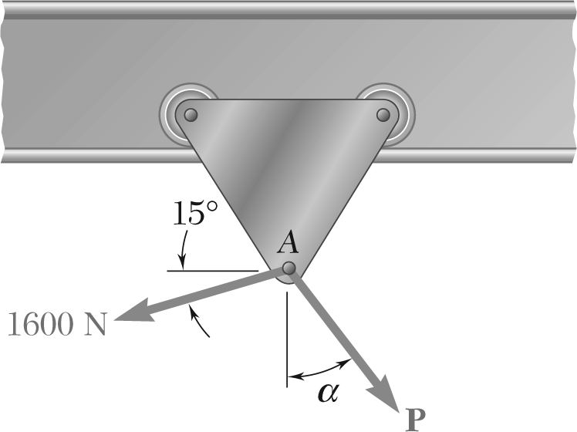

A trolley that moves along a horizontal beam is acted upon by two forces as shown.

*a*) Knowing that α = 25°, determine by trigonometry the magnitude of the force **P** so that the resultant force exerted on the trolley is vertical.

(*b*) What is the corresponding magnitude of the resultant?